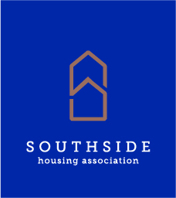

30th October 2025

Dear
Tenant Satisfaction Survey 2025
I am writing to advise that our Tenant Satisfaction Survey that we carry out every three years is going to be carried out by Research Resource, 17B Main Street, Cambuslang on our behalf, between 3rd November and 12th December 2025.
Research Resource will be undertaking the survey to find out your views on the services you receive from us. We use this survey to find out if we are providing the right services to our customers and to check if our services are delivered well or if there are things we need to improve.
Someone from Research Resource may call at your home and ask you to take part in the survey. We encourage you to say “YES”. Their staff will be asking a number of questions based on the services you receive from us, and we would appreciate if you could spare them 10-15 minutes of your time.
Taking part in this survey means you can make a difference to the future services we provide.
Not every tenant is being surveyed; just a percentage based on a random sample so some of your neighbours may not be included. All participants will be entered into a prize draw to win one of 5, £50 shopping vouchers. Entry into this draw will not affect your anonymity.
Please note that the researcher will carry identification.
If you require any further information, please do not hesitate to contact our office on 0141 422 1112 or email at CSD@southside-ha.co.uk.
Thank you for your participation.
Yours sincerely,
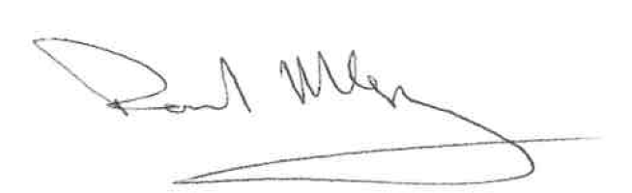
Paul McVey
Chief Executive

