

**Recruitment Pack**

**Property Services Officer**

Closing Date:

Wednesday 5th March 2025 at 12 Noon

**Contents**

|  |  |
| --- | --- |
| Welcome from CEO | 3 |
| About Us | 4 |
| Our Vision & Values | 5 |
| Job Role/Description | 6 |
| Person Specification | 10 |
| Key Relationships | 13 |
| The Selection Process | 13 |
| Summary of Terms | 14 |
| Contact Us | 15 |

**Welcome from the CEO**

**Dear Applicant,**

Thank you for your interest in working with Southside Housing Association as our Property Services Officer. This pack will provide you with details of the role and information about the Association to assist you in the application process.

If you have any questions, or would like to discuss the role further, please contact Aileen Radford – [aradford@southside-ha.co.uk](mailto:aradford@southside-ha.co.uk). In addition, our Director of Property Services, Paul McColgan, is available for an informal confidential discussion. Please arrange this via Aileen Radford.

Should this opportunity be of interest to you, please complete the application form and return to [recruitment@southside-ha.co.uk](mailto:recruitment@southside-ha.co.uk).

Thanks again for your interest and I wish you good luck with your application.

Yours faithfully,

Paul McVey

**Chief Executive Officer**

**Our Vision & Values**

**VISION**

We have a vision to support thriving places and communities.

We want:

* All our homes to be popular, affordable, well-maintained & energy efficient;
  + Our customers to receive excellent services from approachable and knowledgeable staff;
  + To service the needs of all communities equally, and;
  + To work with partners to build popular and inclusive neighbourhoods.

**VALUES**

**Professional**: We will act with integrity, we will be impartial in the advice we give and the actions we take, and we will be reliable and competent in our work.

**Responsive**: We will be focused on both the needs of the individual customer and the community.

**Progressive**: We will seek to empower individuals and communities in our work. We will be proactive in addressing problems and we will tackle inequalities where we find them.

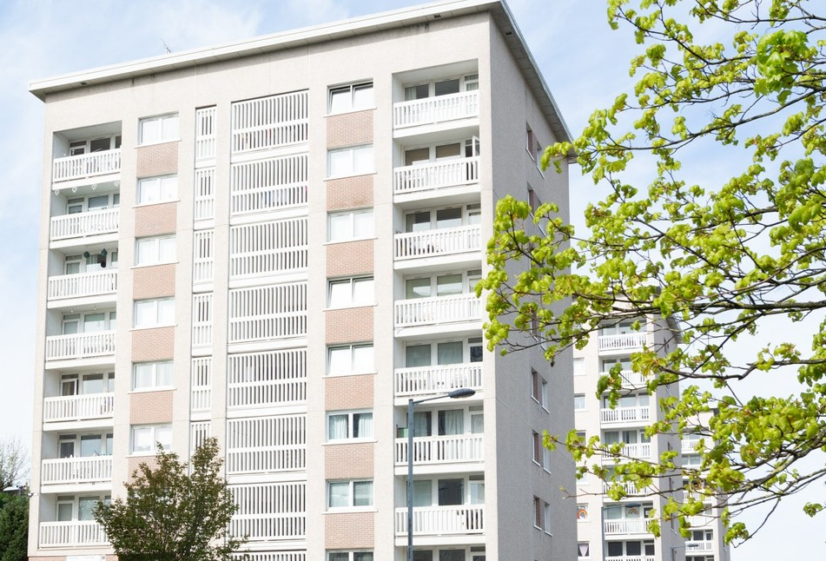

**About us**

At Southside Housing Association (SHA) we care about our community.

SHA is a registered social landlord providing housing and a range of other services across the south side of Glasgow.

We are community controlled which means our decisions are taken by a tenant-controlled Management Committee. We are also a registered Scottish charity (Scottish Charity Number SC036009).

We have operated as a social landlord on the south side of Glasgow for over forty years and currently own and manage approximately 2,250 houses for social rent, provide a factoring service for a further 1,000 owners and through our subsidiary company, Southside Lettings, have a further 250 properties for Mid-Market Rent. We also have an extensive development programme to build new homes.

Over the years we have expanded the range of services we provide to include:

* A variety of housing options & support Money advice & support
* Community events & activities Repairs & maintenance
* Concierge & common area maintenance Handyperson, Home & Hospital and Advice & Information (for older and disabled people living in Glasgow)
* Advice & information on repairs and home improvements (for people who live in Glasgow who are aged 65 and over, or have a disability, irrespective of age).

**Summary of Terms**

**Southside Housing Association is a full member of Employers in Voluntary Housing (EVH) and the terms and conditions for this post follow the EVH Terms.**

**A summary of the principal areas are as follows:**

|  |  |
| --- | --- |
| **Salary** | EVH Grade 7 £39,072 to £42,903 |
| **Salary Payment** | Salary will be paid on 23rd of each month |
| **Contract Status** | Permanent |
| **Hours** | 35 hours per week, Monday to Friday. The office is open to the public Monday to Friday, 9am to 5pm. |
| **Place of work** | Southside Housing Association, Southside House, 135 Fifty Pitches Road, Glasgow, G51 4EB. The Association has onsite parking. |
| **Holiday Entitlement** | 25 days per annum and 15 public holidays per annum |
| **Pension** | The Association offers SHAPS Defined Contribution Pension Scheme (Employee contributions 5% and Employer contributions 10%). New staff are auto-enrolled immediately at the above contribution rate |
| **Notice Period** | 4 weeks |
| **Professional Fees** | One set of professional fees pad per annum |
| **Learning & Development** | We are Investors in Young People accredited and we are committed to investing in our people to ensure that staff members within each department are able to contribute fully to the Associations’ objectives. |
| **Additional Benefits** | The Association has a culture that promotes work/life balance and is supportive of flexible working requests.  Commitment to continued learning and development.  Staff can access Hospital Saturday Fund (at their own cost).  Access to Cycle to Work Scheme. |



**Our Vision**

We have a vision to support thriving places and communities. We want;

* All our homes to be popular, affordable, well-maintained and energy efficient;
* Our customers to receive excellent services from approachable and knowledgeable staff;
* To serve the needs of all communities equally, and;
* To work with partners to build popular and inclusive neighbourhoods.

[To support our vision we are active members of the Scottish Federation of Housing Associations (SFHA),](https://www.sfha.co.uk/) [Glasgow and West of Scotland forum of Housing Association (GWSF)](http://gwsf.org.uk/) and [Employers in Voluntary Housing (EVH).](https://www.evh.org.uk/)

**Our Values**

1. **Respect**

We will put people first, prioritise relationships, be kind and helpful and treat others as we would want to be treated.

1. **Integrity**

We will conduct ourselves with honesty and transparency

1. **Positivity**

We strive for positive outcomes and focus on the solutions that will deliver them

1. **Responsibility**

We will be dependable, professional, reliable and consistent

**Job Role/ Description**

|  |  |  |  |
| --- | --- | --- | --- |
| Job Details | | | |
| **Job Title** | Property Services Officer | **Report to:** | Repairs Services Manager |
| **Department** | Property Services | **Date Created** | October 2022 |
| **Grade** | 7 | **Last Review Date** | November 2023 |
| **Points** | PA22-PA25 | **Salary** | £39,072 - £42,903 |
| Job Summary | | | |
| The Property Services Section’s main aim is to provide our customers with a high quality and customer focused service that maintains our homes to the standards our customers expect. This includes a range of functions such as reactive, void and planned maintenance work and a factoring service, in addition to providing technical knowledge and support to the Association and its customers. We are a highly motivated team committed to promoting the vision and values of the Association. The core skills of the department are administration, communication, problem solving, team working and project management.  The main focus of the Property Services department is to ensure our assets are maintained and improved, whilst ensuring that our customers are satisfied and we work within our budgets. We are committed to ensuring that the legislative responsibilities and compliance requirements are adhered to and we are responsible to our Management Committee for ensuring we provide regular, accurate and specific reports on our activities. As well as this, we contribute to delivering Association-wide strategies and activities, including the delivery of our wider action programme within the communities we serve.  The focus of the Property Services Officer post is to oversee activities, manage services and service delivery and, where required, implement or propose changes or improvements. The officer will provide technical and compliance support primarily to the Repairs Service Manager. It is expected that the post holder will have or is willing to learn the general knowledge and skills for each area in which the team manages. Overall responsibility of the functions and output of the Property Services team is provided by the Director of Property Services who reports to the Chief Executive.  The core skills are administration, including a good working knowledge of Microsoft Office packages as well as a working knowledge of using a database. You must be an excellent communicator (written and verbal), which is key to interacting with our customers, contractors, colleagues and other external agencies. Further, an overall technical competency relating to property maintenance and management is required, as is the understanding and implementing of all health and safety duties placed upon the Association in the management of Contracts and repairs and maintenance. Working effectively and efficiently, both within a team setting and on your own and demonstrating an ability to make informed decisions is crucial to this role.  All staff of the Association must understand and implement the values of Southside Housing Association and understand and adhere to the Terms and Conditions of employment and the Association’s Code of Conduct. Adherence to Equality practices and relevant GDPR and FOI legislation will be expected. | | | |
| Values and Competencies | | | |
| **Southside’s Core Values:**   * Respect – We will put people first, prioritise relationships, be kind and helpful and treat others as we would want to be treated. * Integrity – We will conduct ourselves with honesty and transparency. * Positivity – We strive for positive outcomes and focus on the solutions that will deliver them. * Responsibility – We will be dependable, professional, reliable and consistent   **Core Competency Areas:**   * Communication with staff and external agencies and contractors * Making things happen within your department * Show leadership and inspiration at your level in the organisation.   What does this mean for the postholder:   1. You will demonstrate an awareness and understanding of your role and your place in the team and take responsibility for your actions. 2. You will seek advice and support appropriately from colleagues and line manager. 3. You will be self-motivated, positive and supportive of your colleagues and the Management Committee. 4. You will demonstrate respect, honesty, and professionalism across all areas of your job. 5. You will take responsibility for your development and performance, keeping up to date with new processes and information. 6. You will be able to identify training and learning opportunities. | | | |
| **Job Outputs** | | | |
| **Role Output** | | **Includes the requirement to** | |
| To provide reports and other forms of communications / documents for colleagues including the Repairs Service Manager. | | * To work with excel spreadsheets including creating basic worksheets and filling in worksheets / databases. * To produce technical reports including scope of works, risk assessments and assist in the production of tender documentation. * Work with Microsoft Word and Outlook packages | |
| Assist in the delivery of our Asset Management Strategy when required. | | * Carry out stock condition surveys and provide reports on condition and lifecycles of components as required * Collate and produce technical documents / scope of works and associated information and assist with future procurement exercises. * Assist colleagues and the team in developing and delivering our asset management strategy. * Provide a thorough quality control and contract management regime to ensure works / contracts are carried out by our contractors to expected levels and adherence to conditions of contracts, Health and Safety compliance, including Asbestos, CDM 2015 Regulations, and measured Key Performance Indicators. * Ensure all information is recorded and updated accordingly including all electronic files. * Represent the Association through attendance at contractor meetings, including the production of progress reports relating to the contracts. * Understand and contribute to ensure that we meet our targets towards achieving compliance with current energy efficiency standards and beyond, and to maintain our compliance with SHQS * Ensure that the contractor remains focused on providing our customers with a high quality service throughout the contracts they are awarded. | |
| Assist the team in providing an effective repairs and factoring service to our customers. | | * Carry out pre-inspections to provide our customers with an update on repairs required and to accurately diagnose a scope of works to provide value for money. * Carry out post inspections and update the maintenance data base. * Obtain quotes and instruct repairs where required in line with our authorisation limits and policy. * Operate the in-house database to instruct repairs, check repairs history, run reports and record all relevant documents. * Carry out void inspections, instruct repairs and manage the voids process and contractors in line with our policy and procedures to return void properties to acceptable standards and within required timescales. * Carry out inspections and assist with enquiries from factored owners regarding works or repairs. * Assist others in the collation of information for the Annual Return of the Charter to the Scottish Housing Regulator. | |
| Provide a high quality front line customer service and obtain feedback on the effectiveness of the services we provide | | * Ensure that our customers are kept informed and updated on all aspects of our works where required. * Manage the Associations Complaints Handling process as per our policy and procedures. * Provide assistance on the preparation of information for customers including newsletters, leaflets, website and other social media platforms. * Attend and take part in wider action projects which promote the works and aims of the Association. | |
| Provide Financial and Budgetary Control | | * Approve invoices up to permissible authorisation levels on the in-house electronic invoicing system. * Confirm permission for works, or other costs including variations in line with agreed limits. * Liaise with the Repairs Service Manager on any budgetary information requests. | |
| General Duties | | * Conduct business in accordance with Southside HA’s Policies and Procedures and in line with legislation * Ensure general overall familiarity and competency with all current building, maintenance and associated health and safety legislation and best practices. * Attend training, seminars and conferences as and when required. * Attend and participate in team and other staff meetings. * Assist with other duties as asked for by the Repairs Service Manager, Director of Property Services or Chief Executive in accordance with your Grade. * Respond to out of hours calls as necessary and occasionally attend on site if situation requires | |

**Person Specification**

|  |  |  |  |  |
| --- | --- | --- | --- | --- |
| **Requirements** | **Essential** | **Desirable** | **Method of Assessment** | |
| **Skills & Abilities** | | | **Form** | **Interview** |
| Educated to HND level or equivalent in building, construction, or other relevant professional qualification or demonstrate an acceptable level of transferrable skills and experience. | X |  | ✓ |  |
| Ability to communicate effectively with others and to be an effective listener. | X |  |  | ✓ |
| Demonstrate excellent IT skills relevant to the post / job description. | X |  | ✓ |  |
| Present a positive image at all times both internally and externally  . | X |  |  | ✓ |
| Confident and positive approach to customer care and building strong customer relationships. | X |  |  | ✓ |
| Produce concise, accurate and effective reports to deadlines. | X |  |  | ✓ |
| Demonstrate initiative, flexibility, and decision making in workload and project management. | X |  |  | ✓ |
| **Experience** | | |  |  |
| Providing a quality Clerk of Works and / or Quality Control service and excellent contract management practice for a variety of planned maintenance works and service contracts. |  | x |  | ✓ |
| Carrying out property / component condition surveys. | X |  |  | ✓ |
| Ability to manage contractors effectively. | X |  |  | ✓ |
| Produce accurate detailed documents to assist in the procurement of works / contracts or obtaining quotes. | X |  | ✓ | ✓ |
| Experience in working within a housing maintenance environment for an RSL or local authority housing service. |  | X | ✓ |  |
| Managing void repair contracts |  | X |  | ✓ |
| Manage Aids and Adaptation Process and Installations. |  | X |  | ✓ |
| Dealing with Insurance Claims Processes and managing works. |  | X |  | ✓ |
| Dealing with and resolving complaints. |  | X | ✓ |  |
| Working experience of housing repair systems. |  | X | ✓ |  |
| **Knowledge** | | |  |  |
| Strong working knowledge and understanding of relevant Health & Safety legislation, in particular the CDM 2015 Regulations. | X |  | ✓ | ✓ |
| Understanding of Control of Asbestos, Gas Safety, Water Hygiene, Electrical and other relevant Regulations in accordance with activities. | X |  | ✓ | ✓ |
| A proven ability of working on your own initiative and as part of a team to provide an efficient and effective reactive and planned maintenance service. | X |  |  | ✓ |
| Knowledge of current procurement regulations and processes applicable to an RSL. |  | X |  | ✓ |
| Understand the principles of asset management within an RSL maintenance / property environment. |  | X |  | ✓ |
| General understanding of technical specifications and building standards, including relevant energy efficiency standards. | X |  |  | ✓ |
| Awareness of sustainability in housing design, construction and maintenance. |  | X |  | ✓ |
| Commitment to continuous improvement and quality in all aspects of work. |  | X |  | ✓ |
| **Values/Attitudes** | | |  |  |
| Demonstrate an understanding of equalities. | X |  | ✓ |  |
| Fully understands the principles and practice of Data Protection and Freedom of Information. | X |  | ✓ |  |
| Professional customer focussed approach. | X |  | ✓ | ✓ |
| Ability to find solutions to complex problems. | X |  |  | ✓ |
| **Other Requirements** | | |  |  |
| Full driving licence and use of a car. | X |  | ✓ |  |
| Familiar with the principles of community involvement and promotion of the Association. |  | X |  | ✓ |

**Key Relationships**

|  |  |
| --- | --- |
| **Who?** | **Why?** |
| Director of Property Services | Head of Department |
| Repairs & Voids Manager | Line Manager |
| Property Services Officers/Maintenance Officers | Colleagues |
| Repairs Team | Team Members |
| Contractors | Establish a working relationship to ensure quality service delivery and understanding of expectations |
| Housing Services Team | Work together with colleagues in providing an effective voids management service and on aspects of joint service delivery |

**The Selection Process**

Visit our website for more information and to download an application pack via: [**southside-ha.org/vacancies/**](https://southside-ha.org/vacancies/)

If you need assistance downloading the pack please send an email to [**recruitment@southside-ha.co.uk**](mailto:recruitment@southside-ha.co.uk) and a member of staff will get back to at the earliest opportunity.

|  |  |
| --- | --- |
| **Application** | Please complete the application form.  When completed please return to [recruitment@southside-ha.co.uk](mailto:recruitment@southside-ha.co.uk) |
| **Closing Date** | Wednesday 5th March 2025 at 12 noon. |
| **Interview** | Interview invites will be sent by email. |
| **Place of Interview** | 135 Fifty Pitches Road, Cardonald, G51 4EB. |
|  |  |
|  |  |

**Summary of Terms**

Southside Housing Association is a full member of Employers in Voluntary Housing (EVH) and the terms and conditions for this post follow the EVH terms. A summary of the principal areas are as follows:

|  |  |  |
| --- | --- | --- |
| **Salary** | Employers in Voluntary Housing  Grade 7 - £39,072 - £42,903 | |
|  | | |
| **Salary Payment** | Salary is paid on the 23rd of each month | |
|  | | |
| **Contract Status** | Permanent | |
|  | | |
| **Hours** | 35 hours per week, Monday to Friday. The office is open to the public: 9am-5pm Monday to Friday | |
|  | | |
| **Place of Work** | Southside Housing Association, Southside House, 135 Fifty Pitches Road, Glasgow, G51 4EB. The Association has onsite parking. | |
|  | | |
| **Holiday Entitlement** | 25 days annual leave and 15 public holidays per annum | |
|  | | |
| **Pension** | The Association offers SHAPS Defined Contribution pension scheme (Employee contributions 5% and Employer contributions 10%). New staff are auto-enrolled immediately at the above contributions. | |
|  | | |
| **GDPR** | | You can view the Association’s Fair Processing Notice on our website –  [www.southside-ha.org/data//SHA_Fair_Processing_Notice_](https://www.southside-ha.org/data/SHA_Fair_Processing_Notice___Revised_October_2023_2023_11_02_13_21_47_000.pdf) |



**Contact Us**

recruitment@southside-ha.co.uk

[www.southside-ha.org/working-with-us/](https://www.southside-ha.org/working-with-us/)

0141 422 1112

135 Fifty Pitches Road, Glasgow G51 4EB

