

Recruitment Pack
Housing Administrator
(fixed term for 18 months)

Closing Date:
Friday 19th June 2026 at noon

Contents

Welcome from CEO | 3
About Us | 4
Our Vision & Values | 5
Job Role/Description | 6
Person Specification | 10
Key Relationships | 12
The Selection Process | 12
Summary of Terms | 13
Contact Us | 14

Welcome from the CEO
Dear Applicant,

Thank you for your interest in working with Southside Housing Association as our Housing Administrator. This pack will provide you with details of the role and information about the Association to assist you in the application process.

If you have any questions, or would like to discuss the role further, please contact Aileen Radford – aradford@southside-ha.co.uk. In addition, our Housing Manager, Chris O’Brien, is available for an informal confidential discussion. Please arrange this via Aileen Radford.

Should this opportunity be of interest to you, please complete the application form and return to recruitment@southside-ha.co.uk.

Thanks again for your interest and I wish you good luck with your application.

Yours faithfully,

Paul McVey
Chief Executive Officer

Our Vision & Values

VISION
We have a vision to support thriving places and communities.
We want:
- All our homes to be popular, affordable, well-maintained & energy efficient;
  - Our customers to receive excellent services from approachable and knowledgeable staff;
  - To service the needs of all communities equally, and;
  - To work with partners to build popular and inclusive neighbourhoods.

VALUES
Professional: We will act with integrity, we will be impartial in the advice we give and the actions we take, and we will be reliable and competent in our work.

Responsive: We will be focused on both the needs of the individual customer and the community.

Progressive: We will seek to empower individuals and communities in our work. We will be proactive in addressing problems and we will tackle inequalities where we find them.
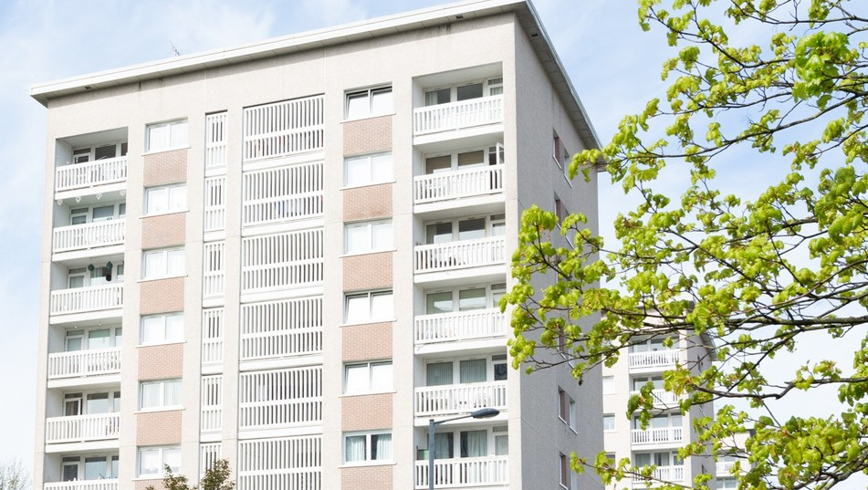

About us

At Southside Housing Association (SHA) we care about our community.

SHA is a registered social landlord providing housing and a range of other services across the south side of Glasgow.

We are community controlled which means our decisions are taken by a tenant-controlled Management Committee. We are also a registered Scottish charity (Scottish Charity Number SC036009).

We have operated as a social landlord on the south side of Glasgow for over forty years and currently own and manage approximately 2,250 houses for social rent, provide a factoring service for a further 1,000 owners and through our subsidiary company, Southside Lettings, have a further 250 properties for Mid-Market Rent. We also have an extensive development programme to build new homes.

Over the years we have expanded the range of services we provide to include:

- A variety of housing options & support Money advice & support
- Community events & activities Repairs & maintenance
- Concierge & common area maintenance

Summary of Terms

Southside Housing Association is a full member of Employers in Voluntary Housing (EVH) and the terms and conditions for this post follow the EVH Terms.
A summary of the principal areas are as follows:

Salary | EVH Grade 7 £39,072 to £42,903
Salary Payment | Salary will be paid on 23rd of each month
Contract Status | Permanent
Hours | 35 hours per week, Monday to Friday. The office is open to the public Monday to Friday, 9am to 5pm.
Place of work | Southside Housing Association, Southside House, 135 Fifty Pitches Road, Glasgow, G51 4EB. The Association has onsite parking.
Holiday Entitlement | 25 days per annum and 15 public holidays per annum
Pension | The Association offers SHAPS Defined Contribution Pension Scheme (Employee contributions 5% and Employer contributions 10%). New staff are auto-enrolled immediately at the above contribution rate
Notice Period | 4 weeks
Professional Fees | One set of professional fees pad per annum
Learning & Development | We are Investors in Young People accredited and we are committed to investing in our people to ensure that staff members within each department are able to contribute fully to the Associations’ objectives.
Additional Benefits | The Association has a culture that promotes work/life balance and is supportive of flexible working requests.  Commitment to continued learning and development.  Staff can access Hospital Saturday Fund (at their own cost).  Access to Cycle to Work Scheme.

Our Vision

We have a vision to support thriving places and communities. We want;

- All our homes to be popular, affordable, well-maintained and energy efficient;
- Our customers to receive excellent services from approachable and knowledgeable staff;
- To serve the needs of all communities equally, and;
- To work with partners to build popular and inclusive neighbourhoods.

To support our vision we are active members of the Scottish Federation of Housing Associations (SFHA), Glasgow and West of Scotland forum of Housing Association (GWSF) and Employers in Voluntary Housing (EVH).

Our Values
- Respect
We will put people first, prioritise relationships, be kind and helpful and treat others as we would want to be treated.

- Integrity
We will conduct ourselves with honesty and transparency

- Positivity
We strive for positive outcomes and focus on the solutions that will deliver them

- Responsibility
We will be dependable, professional, reliable and consistent

Job Role/ Description

Job Details

Job Title | Housing Administrator | Report to: | Housing Manager
Department | Housing and Communities | Date Created | June 2024
Grade | 4 | Last Review Date | June 2026
Points | PA9-PA12 | Salary | £27,068 - £30,610
Job Summary
Our Housing Management Section is made up of 2 Neighbourhood teams and 1 Allocations team, each led by a Housing Manager. The Housing Administrator role will sit within the Neighbourhood team and will provide administrative support to the Housing Management section.
The role of Housing Administrator will contribute to delivering a dynamic Housing Management service which is located within the Housing and Communities Department. The role will work closely with all members of the Housing Management Section and will deliver an excellent service to our social rent, mid-market rent customers and the wider public. The wider role of the section is to provide our customers with a high standard of service and support, ensuring that rental income is maximised, estates are well maintained, tenant issues and support needs are dealt with, and antisocial behaviour is managed. The Housing Administrator will play a key administrative role in achieving this.
The Housing Administrator will be well trained and highly motivated which will strengthen the engagement and participation from the communities we serve and colleagues we support. This includes a variety of contact methods such as telephone, face to face, email and digital. We are a highly motivated department, committed to promoting the vision and values of the Association. The core skills of the role are having a customer-centric approach, excellent communication, problem solving and team working.

The focus of the Housing Administrator post is to address all customer enquiries in a helpful, welcoming and professional manner, providing advice and assistance to customers on a wide range of issues at the first point of contact. It is key to establish, develop and maintain effective working relationships with work colleagues, contractors and partnering agencies to ensure that the needs of the customer are met. When necessary, complaints should be dealt with politely and promptly in accordance with Association & regulatory guidelines. Seeking a stage one resolution or taking ownership when required, liaising internally for further support and escalating appropriately. Overall responsibility of the functions and output of the Housing and Communities Department is provided by the Director of Housing and Communities who reports to the Chief Executive Officer.

The core skills include displaying the confidence to support customers while balancing organisational priorities. It is expected that the post holder will be an excellent communicator (written and verbal), which is key to interacting with our customers, contractors, colleagues and other external agencies. Working effectively and efficiently, both within a team setting and on your own initiative as well as demonstrating an ability to make informed decisions, resolve enquiries, and know when to seek advice or escalate matters. A good working knowledge of Microsoft 365 and housing management systems is key, whilst having the ability to multitask and focus on the customer.

All staff of the Association must understand and implement the values of Southside Housing Association and understand and adhere to the Terms and Conditions of employment and the Association’s Code of Conduct. Adherence to Equality practices and relevant GDPR and FOI legislation will be expected.

Values and Competencies
Southside’s Core Values:

- Respect We will put people first, prioritise relationships, be kind and helpful
and treat others as we would want to be treated.
- Integrity We will conduct ourselves with honesty and transparency.

- Positivity We will always look for positive outcomes and be solutions focused.

- Responsibility We will be dependable, professional, reliable and consistent.

Core Competency Areas:

- Communication with staff and external agencies and contractors
- Making things happen within your department
- Show leadership and initiative at your level in the organisation.

What does this mean for the post holder:

- You will demonstrate an awareness and understanding of your role and your place in the team and take responsibility for your actions.
- You will seek advice and support appropriately from colleagues and line manager.
- You will be self-motivated, positive and supportive of your colleagues and the Management Board.
- You will demonstrate respect, honesty, and professionalism across all areas of your job.
- You will take responsibility for your development and performance, keeping up to date with new processes and information.
- You will be able to identify training and learning opportunities.

Job Outputs

Role Output |  | Includes the requirement to
Provide a warm welcome to visitors, providing a positive first impression |  | - Provide reception duties as required at our offices and welcome and assist visitors/contractors, ensuring all necessary logs are maintained.  - Update our Housing Management system and other customer systems to maintain detailed and accurate information in accordance with the Data Protection Act and GDPR.  - Communicate professionally with our customers, contractors and partner agencies.
Support customers through a variety of contact methods such as telephone, email and digital. |  | - Address all customer enquiries in a helpful, friendly and professional manner.  - Deal with rent accounts, estate management and tenancy management queries, referring to the wider housing management staff for advice and support.  - Respond to complaints politely and promptly in accordance with our complaint handling procedure. Seeking to resolve complaints at first point of contact (Stage 1) where appropriate and escalating in line with procedure.  - Field enquiries relating to the allocations system and provide general advice and assistance to applicants regarding re-housing, referring to the Housing Officers where necessary.  - Participate in proactive customer engagement in relation to welfare, support and relevant sign posting where appropriate.  - Process telephone payments for rent, service charges, etc and provide basic information and advice to tenants in arrears.
Provide a high quality front line customer service and obtain feedback on the effectiveness of the services we provide |  | - Ensure that our customers are kept informed and updated on all aspects of our works where required.  - Provide assistance on the preparation of information for customers including newsletters, leaflets, website and other social media platforms.  - Attend and support community projects which promote the work and aims of the Association.
General Duties |  | - Conduct your role in accordance with Southside HA’s Policies and Procedures and in line with legislation.  - Ensure all records, case notes and customer information is maintained accurately and in a timely manner in line with policies and GDPR requirements.  - Keep abreast of legislative developments affecting your area of work and undertake training and continual professional development to keep up to date with the Association’s changing requirements.  - Attend staff meetings and courses when required, and positively contribute to the collective strength of the department and Association.  - Attend appraisals on a regular basis, participate in peer support and opportunities for personal development maintaining evidence of this.  - Any other duties consistent with the post as required
Leadership and Team Working |  | - Have a problem-solving attitude.  - Be approachable and open to listening, learning from others, and adapting.  - Lead by example.  - Be challenging of behaviours, attitudes and communication that is not in fitting with our values.

Person Specification

Requirements |  |  | Method of Assessment
Experience, Knowledge and Understanding | Essential | Desirable | Form | Interview
Experience of working in a customer service environment, handling enquiries across multiple channels (face to face, telephone, email and digital). | * |  | * | *
Experience of providing excellent front-line customer service, including dealing with vulnerable customers in a sensitive manner. | * |  | * | *
Experience of working in an administrative role, maintaining accurate records and supporting colleagues to maximise team performance. | * |  | * | *
Experience of working with a wide range of colleagues, contractors and other external partners to support customer needs. | * |  | * | *
Experience of working in social housing in either a local authority, housing association or voluntary sector role. |  | * | *
Experience of dealing with housing-related enquiries (e.g rent, estate management, tenancy queries, anti-social behaviour. |  | * | * | *
Experience of multi-tasking and managing competing priorities while maintaining a strong customer focus. | * |  | * | *
Qualifications and Training | Essential | Desirable | Form | Interview
Educated to National 5 higher or advanced level or equivalent, or transferable skills and experience | * |  | *
A commitment to continuous professional development (CPD), including a willingness to develop knowledge and skills in required areas. | * |  | *
Skills and Abilities | Essential | Desirable | Form | Interview
Excellent interpersonal and communication skills (written and verbal) | * |  | * | *
Competent in the use of computerised systems i.e. Microsoft 365 / Sharepoint / Housing Management system | * |  | *
Ability to maintain accurate records and process information in line with GDPR and data protection requirements | * |  | * | *
Track record of providing excellent front-line customer service including dealing with vulnerable customers in a sensitive manner | * |  |  | *
Ability to communicate effectively with others and to be a good listener. | * |  | * | *
Ability to prioritise work to meet deadlines, reacting positively to changing priorities. | * |  | * | *
Ability to work on own initiative and as part of a team. | * |  | * | *
Ability to demonstrate an understanding of equalities legislation and experience of working with diverse, vulnerable and marginalised communities. | * |  |  | *
Personal Features/ Qualities | Essential | Desirable | Form | Interview
Professional customer focused approach. | * |  |  | *
An effective team player who takes responsibility and is capable of coping with changing circumstances and demands. | * |  |  | *
Strong organisational and time management skills with the ability to manage day to day workload with minimal supervision | * |  |  | *
Understanding of, and commitment to, the aims, values and principles of Southside Housing Association | * |  | * | *

Key Relationships

Who? | Why?
Director of Housing and Communities | Head of Department
Housing Management Team | Line Manager and peers for advice, guidance and support on all aspects of Housing Management
Welfare Rights Team | For advice, guidance and support on all aspects of welfare rights.

The Selection Process

Visit our website for more information and to download an application pack via: southside-ha.org/vacancies/

If you need assistance downloading the pack please send an email to recruitment@southside-ha.co.uk and a member of staff will get back to at the earliest opportunity.

Application | Please send your completed application form, Equalities Form and criminal convictions form to recruitment@southside-ha.co.uk
Closing Date | Friday 19th June 2026 at noon
Interview | Interview invites will be sent by email.
Place of Interview | 135 Fifty Pitches Road, Cardonald, G51 4EB.
Interview Dates | Interviews will take place on 26th June 2026

Summary of Terms
Southside Housing Association is a full member of Employers in Voluntary Housing (EVH) and the terms and conditions for this post follow the EVH terms. A summary of the principal areas are as follows:

Salary | Employers in Voluntary Housing  Grade 4 - £27,068 - £30,610
Salary Payment | Salary is paid on the 23rd of each month
Contract Status | Fixed Term – 18 months
Hours | 35 hours per week. The office is open to the public: 9am-5pm Monday to Friday
Place of Work | Southside Housing Association, Southside House, 135 Fifty Pitches Road, Glasgow, G51 4EB. The Association has onsite parking.  (Occasional working at our local office at 435 Shields Road, Glasgow, G41 1NP will also be required).
Holiday Entitlement | 25 days annual leave and 15 public holidays per annum
Pension | The Association offers SHAPS Defined Contribution pension scheme (Employee contributions 5% and Employer contributions 10%). New staff are auto-enrolled immediately at the above contributions.
GDPR |  | You can view the Association’s Fair Processing Notice on our website –  www.southside-ha.org/data//SHA_Fair_Processing_Notice_



Contact Us

recruitment@southside-ha.co.uk

www.southside-ha.org/working-with-us/

0141 422 1112

135 Fifty Pitches Road, Glasgow G51 4EB

